**Lab Report**

Title: Lab 2 Part 2

Notice: Dr. Bryan Runck

Author: Zhaoxu Sui

Date: 10/26/2021

**Project Repository: https://github.com/KennethSui/GIS5571/tree/main/lab2**

**Google Drive Link: https://drive.google.com/drive/folders/1qw0Werk9F63C6FkLkBe_iKm4xs2LZnQ1?usp=sharing**

**Time Spent:** 10 hours

**Abstract**

In this project, I created an ETL for data to go into a cost surface model under an imaginary scenario. Firstly, I download the Land Cover data and elevation data to create a cost surface model. Then, I used the optimal regional connection tool to map the range of cost surfaces given uncertain preferences and model weights

**Problem Statement**

My objective is to use map algebra and cost modeling to create a cost surface for walking for an imaginary person named Dory, and then understand how uncertainty in model weights impacts that cost surface. Dory have several preferences and places that avoid to bypass, like farms, waters, or steep roads.

*Sheet 1: Required Datasets for this lab task*

|  |  |  |  |  |  |  |
| --- | --- | --- | --- | --- | --- | --- |
| **#** | **Requirement** | **Defined As** | **(Spatial) Data** | **Attribute Data** | **Dataset** | **Preparation** |
| 1 | State Park Boundaries or Locations | A database which could represent the Whitewater State Park’s location. | Shapefile |  | MN Geospatial Commons | Derived from Notebook |
| 2 | Land Use Classification | A land cover dataset which could at least represent farm fields and water bodies. | Raster file,  TIFF might be the best |  | MN Geospatial Commons | Derived from Notebook |
| 3 | Elevation Data | A DEM dataset which helps identify the relief of Southeast Minnesota | Raster file,  TIFF might be the best |  | MN Geospatial Commons | Derived from Notebook |

**Input Data**

*Sheet 2: Input datasets*

|  |  |  |  |
| --- | --- | --- | --- |
| **#** | **Title** | **Purpose in Analysis** | **Link to Source** |
| 1 | Minnesota Land Cover Classification and Impervious Surface Area by Landsat and Lidar: 2013 update - Version 2 | To re-weight each kinds of the land use classification to better exclude that Dory avoid to bypass. | [Mn GeoSpatial Commons](https://gisdata.mn.gov/dataset/base-landcover-minnesota) |
| 2 | State Parks, Recreation Areas, and Waysides | To identify the desired destination of Dory | [Mn GeoSpatial Commons](https://gisdata.mn.gov/dataset/bdry-dnr-lrs-prk) |
| 3 | Lidar Elevation, Southeast Minnesota, 2008 | To find the most gradual slopes of Dory | [Mn GeoSpatial Commons](https://gisdata.mn.gov/dataset/elev-lidar-semn2008) |

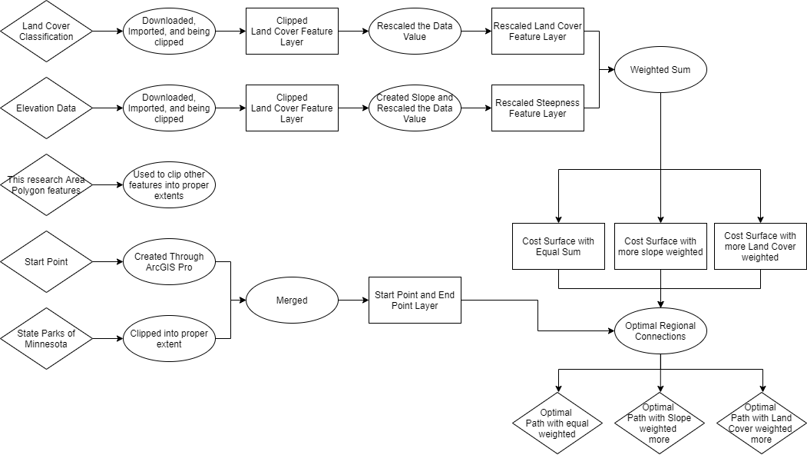**Methods**

Figure Please enlarge it to see details

The whole process is programmed in the ArcGIS Pro notebook with the utilization of Arcpy functions as well as trivial manual manipulations in the ArcGIS Pro.

Firstly, I download the both the land cover dataset and the Elevation Dataset from MN DNR. I clipped them into proper extent and rescaled them. For the Land Cover Dataset, I gave water bodies, wetlands, and farmlands higher values from 8 to 10 and gave artificial surfaces and forests lower values from 0 to 3. For the elevation data, I transformed it into a slope graph, and rescaled it automatically, with the steeper area given higher value, and smoother area given lower value.

Secondly, I downloaded the state parks dataset to find the Whitewater state park. Merged the point of the park and with the start point that derived from x y table. Thus, we have a point layer contains the start point and the end point.

Thirdly, I used the weighted sum function to merge the rescaled Land Cover layer and the Slope layer together and did this operation three times.

The first time I put the Land Cover and the Slope into a equal weighted option with assigned both values 1.

The Second time I weighted Slope more with value of 10, but land cover remains the 1.

The Third time I weighted Land Cover more with value of 10, but slope remains at 1.

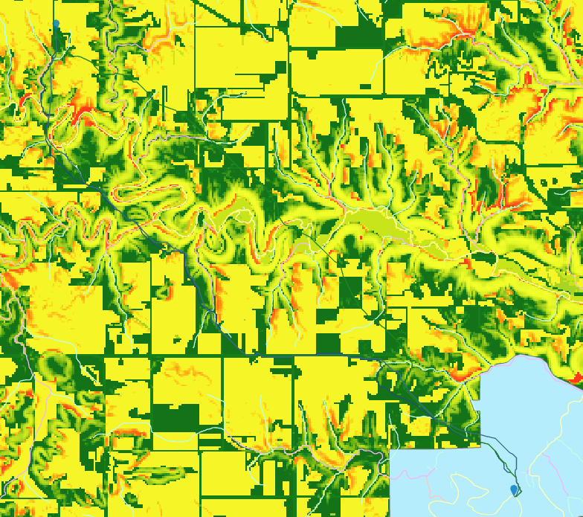

Figure 2 Equal Weight Option, which shows the green areas as suitable for bypassing while red areas not suitable for walking by.

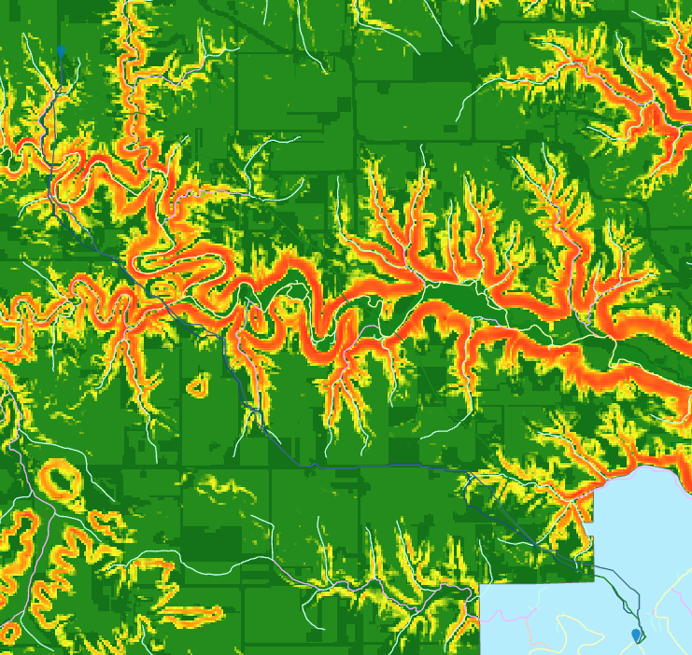

Figure 3 Slope Veighted More than the Land Cover

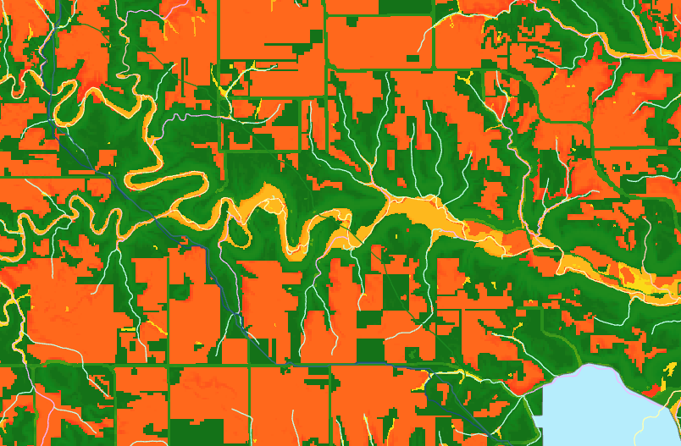

Figure 4 Land Cover Weighted more than the Slope

After the weighted sum operations, I used the optimal regional connections tool to calculate three different routes of choice under the scenario of different weighted cost surfaces. You can directly see the graph below.

**Results**

After the computation, I found the equal weight option and the land use option are similar, while the slope weighted option is deflected.

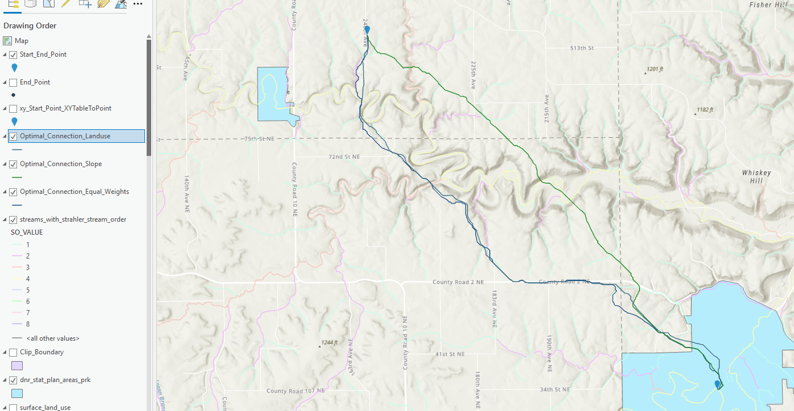

Figure 5 Optimal Paths of all three options.

**Results Verification**

All the data are through carefully examined and verified. Except the result codes in the Jupyter notebooks, the pictures above also shows that the approach of making these results make sense.

**Discussion and Conclusion**

At first, I wanted to import a river vector layer, but I found it is hard to find and use a suitable vector layer data of rivers and streams in this area. Because there is literally a stream cut through the start point and the end point, which means it is not realistic to bypass rivers in this area. I hope there could be better algorithms calculating the widths and depths of rivers to neglect some small streams.

As a result, in this exercise, all the water bodies were only reflected in the raster layer instead of vector river layers.

I would also like to see why the equal weight option and the land use option are similar, might be because of the improper rescaling. I would like to research more on the rescaling methods.

This is a wonderful lab exercise, composed by two meaningful parts, and I witnessed and practiced how the GIS software can make difference to our life.

**References**

Creating a surface raster, Esri. Last Retrieved in 2021. https://pro.arcgis.com/en/pro-app/latest/tool-reference/spatial-analyst/creating-a-cost-surface-raster.htm

**Self-score**

*Fill out this rubric for yourself and include it in your lab report. The same rubric will be used to generate a grade in proportion to the points assigned in the syllabus to the assignment.*

|  |  |  |  |
| --- | --- | --- | --- |
| **Category** | **Description** | **Points Possible** | **Score** |
| **Structural Elements** | All elements of a lab report are included **(2 points each)**:  Title, Notice: Dr. Bryan Runck, Author, Project Repository, Date, Abstract, Problem Statement, Input Data w/ tables, Methods w/ Data, Flow Diagrams, Results, Results Verification, Discussion and Conclusion, References in common format, Self-score | 28 | **26** |
| **Clarity of Content** | Each element above is executed at a professional level so that someone can understand the goal, data, methods, results, and their validity and implications in a 5 minute reading at a cursory-level, and in a 30 minute meeting at a deep level **(12 points)**. There is a clear connection from data to results to discussion and conclusion **(12 points)**. | 24 | **22** |
| **Reproducibility** | Results are completely reproducible by someone with basic GIS training. There is no ambiguity in data flow or rationale for data operations. Every step is documented and justified. | 28 | **28** |
| **Verification** | Results are correct in that they have been verified in comparison to some standard. The standard is clearly stated **(10 points)**, the method of comparison is clearly stated **(5 points)**, and the result of verification is clearly stated **(5 points)**. | 20 | **19** |
|  |  | 100 | **95** |